The java files are commited in the branch 1.0.6 (amp-aicore)

Index 2 (Java) webscript:

Those files hve to be copied in Data Dictionary > Web Scripts > org > amnesty > library

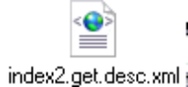

Index (Javascript) webscript



Copy in the same folder Data Dictionary > Web Scripts > org > amnesty > library

You also need the include.js file

Copy it into Data Dictionary > Web Scripts > org > amnesty > include

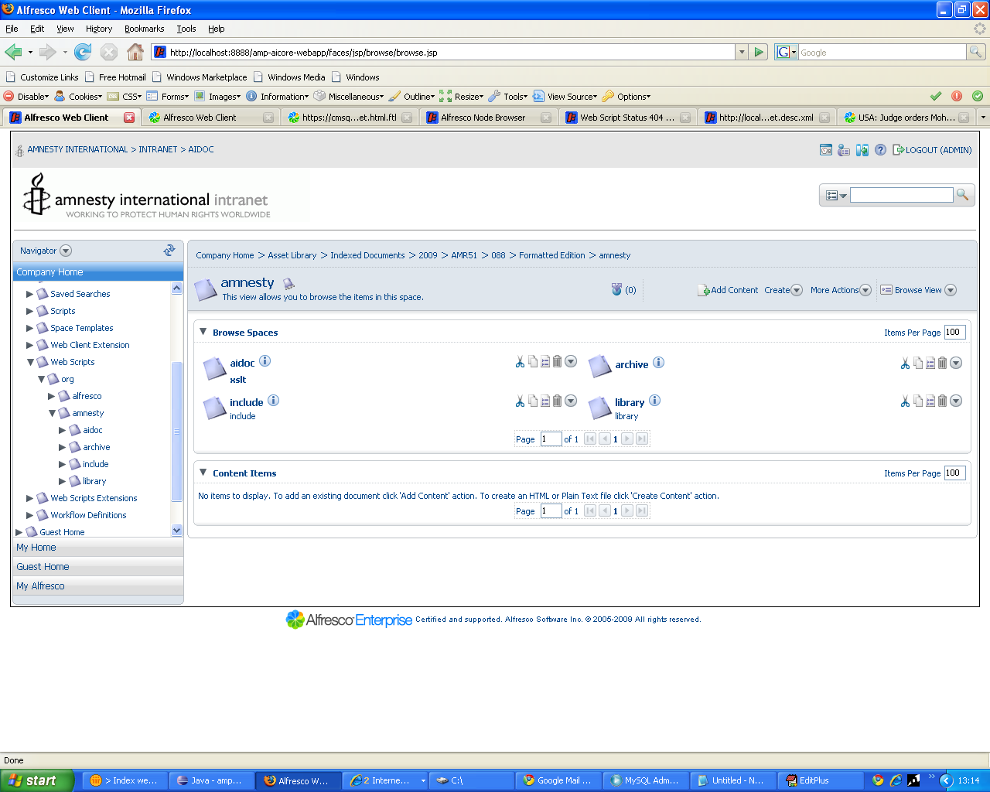

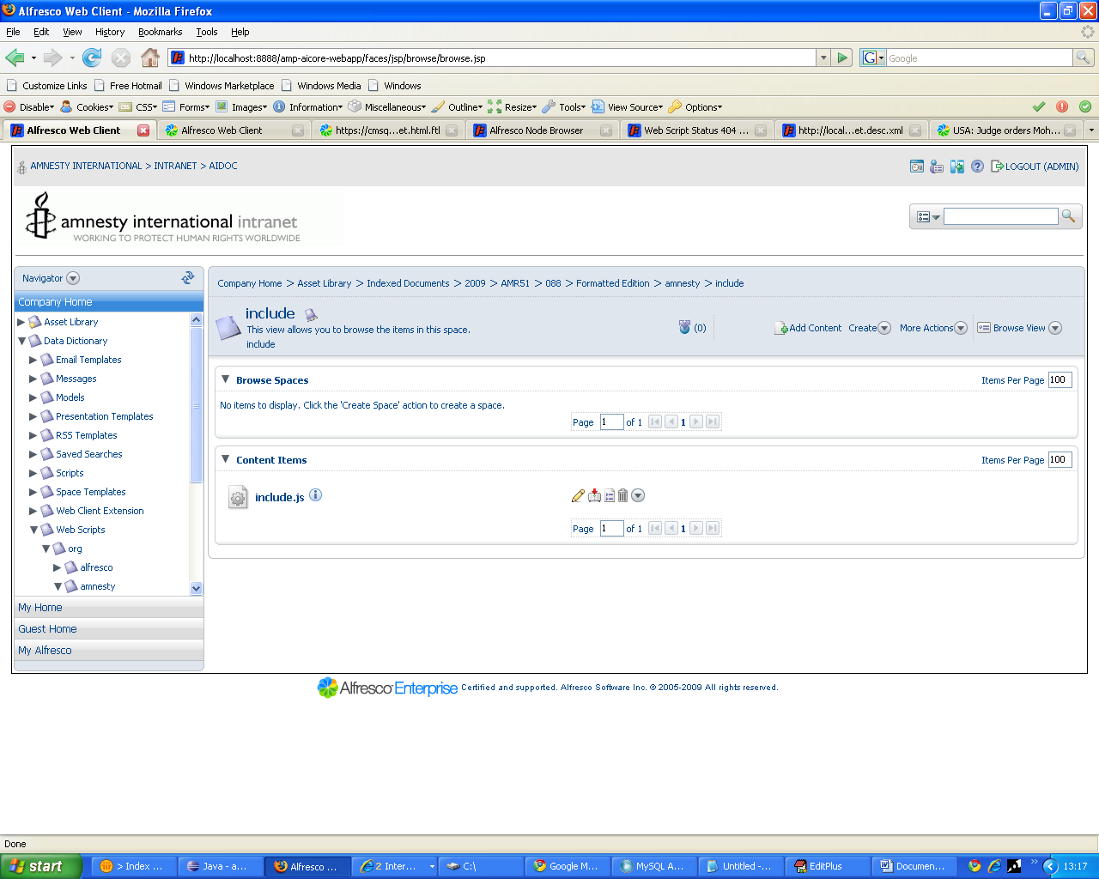

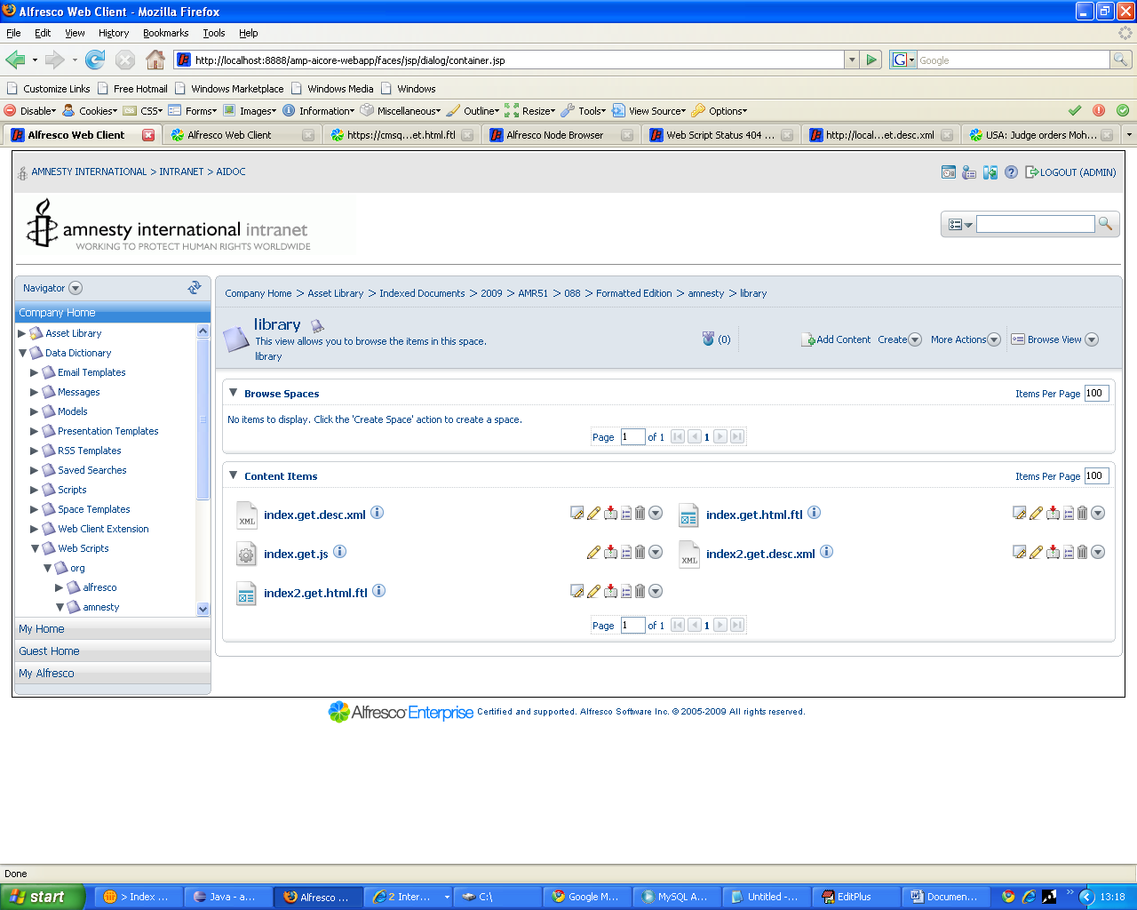

http://localhost:8888/amp-aicore-webapp/service/index
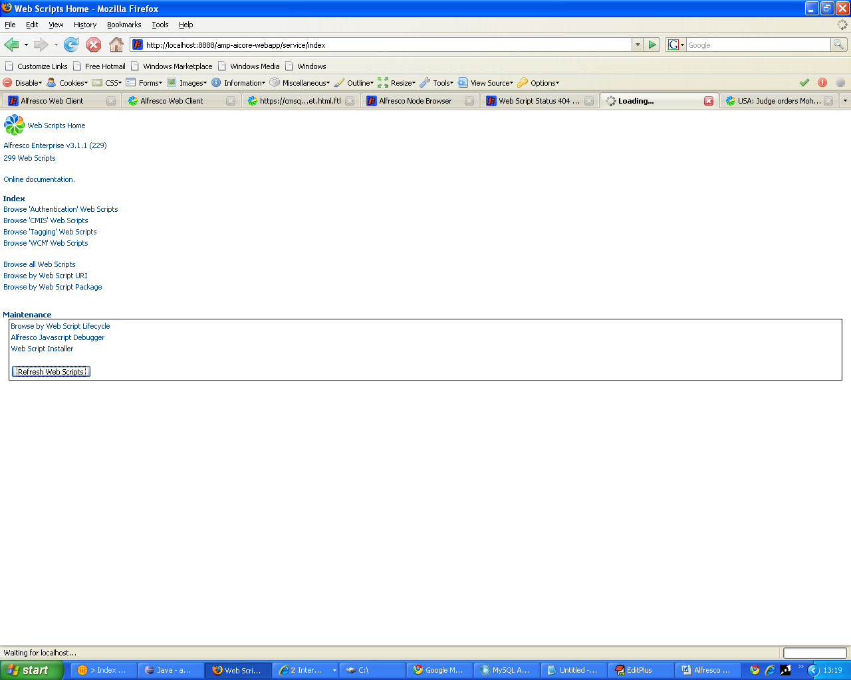

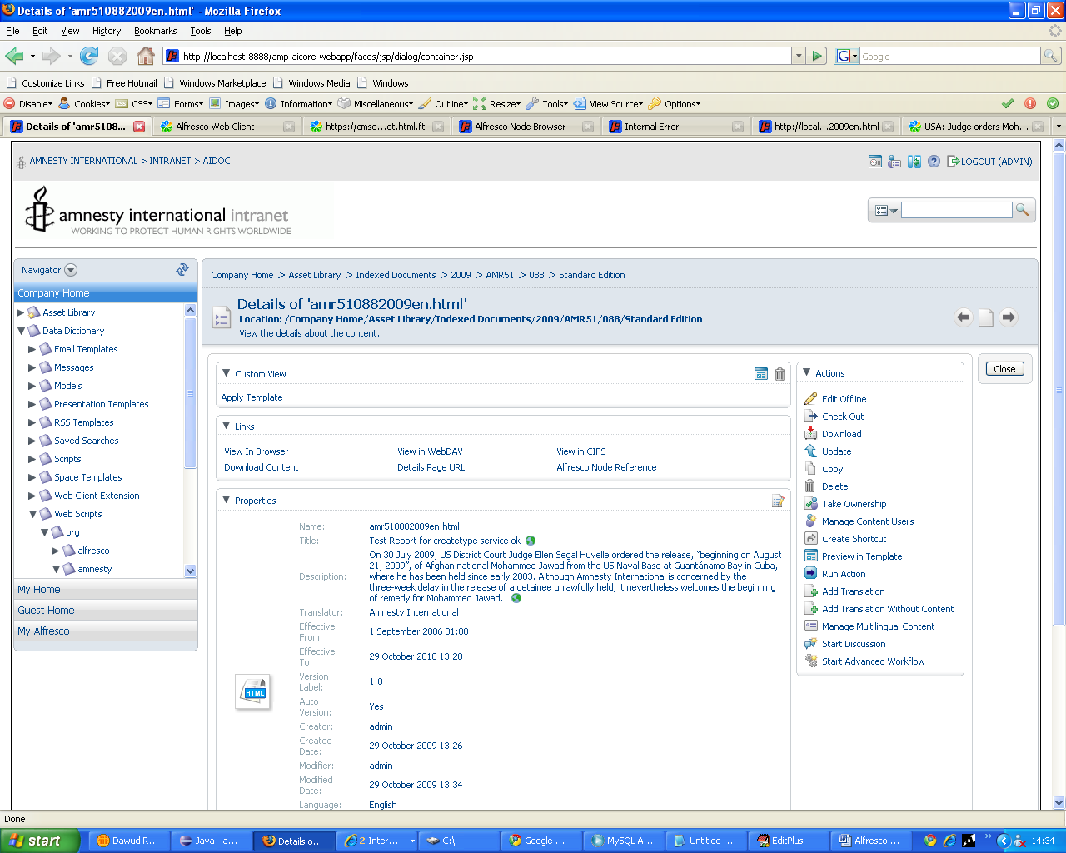
http://localhost:8888/amp-aicore-webapp/service/library/index2/2009/AMR51/088

